Commentary >> Third Party Commentary >> Symposium Papers (CPA Canada Commodity Tax) >> 2013 (Ottawa, September 30-October 1) >> 4. Hot Customs Topics for 2013

HOT CUSTOMS TOPICS FOR 2013
By: Daniel L. Kiselbach, Deloitte Tax Law LLP

1. CBSA Targeted Priorities
In January of this year, the Canada Border Services Agency ("CBSA") released its list of "targeted priorities" for 2013.1 The list was updated in July.2 Targeted priorities relate to areas with a significant risk of non-compliance. Targeted priorities and random verification are the two post-release verification processes that the CBSA uses to ensure compliance with the Tariff Classification, Tariff Treatment, Valuation, and Origin programs.
Businesses that import goods that are targeted priorities should be aware that the CBSA could perform a customs compliance verification audit on them. It is prudent for such businesses to review their compliance with tariff classification, valuation, and origin determination, so that errors or omissions can be corrected before they are caught by a compliance verification audit.
The following is the list of targeted priorities released in January.
 | Tariff Classification | HS Number(s)
1. | Pet Toys | 9503.00.90
2. | Steel T-Posts | 7308.40.00.90
3. | Fresh Cut Flowers | 0603.19.00
4. | Safety Headgear | 6506.10.10.90
5. | Wheel Rims and Spokes | 8714.92.00
6. | Other Food Preparations | 2106.90.95
7. | Dextrins and Other Modified Starches | 3505.10.90
8. | Tariff Item 9948.00.00  (Televisions and Other Consumer Goods) | 9948.00.00
9. | Coconut Milk | 1106.30.00; 2008.19.90 and 2106.90.10.20
10. | Pickles | 2001.90.90.91
11. | Golf Club Covers | 9506.39.90.90
12. | Curling Irons | 8516.32.10
13. | Aluminum Foil | Various goods of Heading 76.07
14. | Disposable and Protective Gloves | 3926.20.10 and 4015.19.10
15. | Spectacle Lenses | 9001.40.10 and 9001.50.10
16. | Tariff Item 9908.00.00 (Mining Industry) | 9908.00.00
 | Valuation | HS Number(s)
17. | Fresh Cut Flowers | 0603.19.00
18. | Apparel | Various goods of Chapters 61 and 62
19. | Footwear | Various goods of Chapter 64
20. | Yachts for Pleasure or Sport | Various goods of Heading 89.03
21. | Preparations and Pastrycooks' Products | Various goods of Chapter 19
 | Origin | HS Number(s)
22. | Bedding and Drapery | Various goods of Headings 63.01, 63.02 and 63.03
23. | Cocoa Powder | 1805.00.00 and 1806.10.90
24. | Mattress Upholstery | Various goods of Chapters 54, 55 and 60
25. | Frozen Crab | 0306.14.90
26. | Cotton Pants | 6203.42
The following is the list of targeted priorities released in July. These will be the CBSA's targeted priorities for the rest of 2013.
 | Tariff Classification | HS Number(s)
1. | Fresh Cut Flowers | 0603.19.00
2. | Pickles | 2001.90.90.91
3. | Golf Club Covers | 9506.39.90.90
4. | Curling Irons | 8516.32.10
5. | Aluminum Foil | Various goods of Heading 76.07
6. | Disposable and Protective Gloves | 3926.20.10 and 4015.19.10
7. | Furniture for Non-Domestic Purposes | Various goods of Headings 94.01 and 94.03
8. | Spectacle Lenses | 9001.40.10 and 9001.50.10
9. | Palm Oil | 1511.90.10 and 1511.90.20
10. | Chemical Products | Various goods of Heading 38.08
11. | Safety Headgear (Round 2) | 6506.10.10.90
12. | Seaweed (Round 2) | 1212.21.00 and 1212.29.00
13. | Dextrins and Other Modified Starches (Round 2) | 3505.10.90
 | Valuation | HS Number(s)
14. | Fresh Cut Flowers | 0603.19.00
15. | Apparel | Various goods of Chapters 61 and 62
16. | Footwear | Various goods of Chapter 64
17. | Yachts for Pleasure or Sport | Various goods of Heading 89.03
18. | Preparations and Pastrycooks' Products | Various goods of Chapter 19
 | Origin | HS Number(s)
19. | Bedding and Drapery | Various goods of Headings 63.01, 63.02 and 63.03
20. | Mattress Upholstery | Various goods of Chapters 54, 55 and 60
21. | Frozen Crab | 0306.14.90
22. | Cotton Pants | 6203.42
23. | T-Shirts | Heading 61.09

2. Tariff Relief
The 2013 Federal Budget announced $76 million in annual tariff relief on baby clothing and athletic equipment. Such items had a higher price in Canada than in the United States, and this measure is meant to reduce that gap.3
The change eliminates all tariffs on baby clothing. Athletic equipment that will no longer be subject to tariffs includes the following: exercise equipment, golf clubs, hockey equipment, ice skates, and skis and snowboards. The changes took effect as of April 1, 2013.4 The following table demonstrates the type of tariff relief that is being provided.5
Product | Old Tariff | New Tariff as of April 1, 2013
Baby Clothing | 18% | Free
Exercise Equipment | 6.5% | Free
Golf Clubs | 2.5% to 7% | Free
Hockey Equipment | 2.5% to 18% | Free
Ice Skates | 18% | Free
Skis and Snowboards | 6.5% to 20% | Free
The Federal Government hopes that these reductions will be passed onto consumers. The Federal Government has stated the following:
This initiative will allow the Government to assess whether tariff elimination can help narrow the price gap for consumers in Canada, and will help guide future decisions. The Government will continue working with Canadians, including consumers, retailers and manufacturers, to identify areas where further tariff liberalization can benefit Canada.6
It appears the Federal Government is seriously considering further tariff reduction/elimination.

3. "Modernizing" the GPT
The 2013 Federal Budget also announced major changes to the General Preferential Tariff ("GPT"). The policy behind the GPT is to promote economic growth in developing countries by offering low tariff rates for imports from such countries.7 The Federal Government plans to "graduate" 72 more developed countries and no longer allow them to be eligible for the GPT. The change is scheduled to take effect January 1, 2015.8 The 2013 Federal Budget estimates that the changes in the GPT will result in annual savings of $83 million in 2014-15 and $333 million in 2015-16 and future years.9
GPT eligibility will be withdrawn from the following countries.10
Algeria | Croatia | Kuwait | Saint Lucia
American Samoa | Cuba | Lebanon | Saint Vincent and
Antigua and Barbuda | Dominica | Macao | the Grenadines
Antilles, Netherlands | Dominican Republic | Macedonia | Seychelles
Argentina | Ecuador | Malaysia | Singapore
Azerbaijan | Equatorial Guinea | Maldives | South Africa
Bahamas | French Polynesia | Mariana Islands | South Korea
Bahrain | Gabon | Mauritius | Suriname
Barbados | Gibraltar | Mexico | Thailand
Bermuda | Grenada | Namibia | Trinidad and Tobago
Bosnia and Herzegovina | Guam | New Caledonia and Dependencies | Tunisia
Botswana | Hong Kong | New Caledonia and Dependencies | Turkey
Brazil | India | Oman | Turks and Caicos Islands
Brunei | Indonesia | Palau | United Arab Emirates
Cayman Islands | Iran | Panama | Uruguay
Chile | Israel | Peru | Venezuela
China | Jamaica | Qatar | Virgin Islands, U.S.A.
Colombia | Jordan | Russia
Costa Rica | Kazakhstan | Saint Kitts and Nevis
The 2013 Federal Budget also announced that the GPT would be renewed for a further 10 years, and going forward the Federal Government will bi-annually review which countries can receive the benefit of the GPT.11
The reduction in countries eligible for the GPT will cause numerous imports to increase to most-favoured-nation tariff rates. The effect on imports into Canada will be significant. It is recommended that importers begin to prepare now for the change.

4. Trans-Pacific Partnership ("TPP")
Canada is currently in 14 separate free trade negotiations, including negotiations for a Comprehensive Economic and Trade Agreement with the European Union and the TPP. The free trade negotiations are with the following:
• Andean Community Countries (Bolivia, Colombia, Ecuador, and Peru);
• Caribbean Community (Antigua and Barbuda, The Bahamas, Barbados, Belize, Dominica, Grenada, Guyana, Haiti, Jamaica, Montserrat, Saint Lucia, St. Kitts and Nevis, St. Vincent and the Grenadines, Suriname, Trinidad and Tobago);
• El Salvador, Guatemala, and Nicaragua (formerly the Central American Four negotiations);
• Costa Rica (negotiations to modernize the current free trade agreement);
• Dominican Republic;
• India;
• Japan;
• Korea;
• Morocco;
• Singapore;
• Turkey;
• Ukraine.12
The TPP, in particular, could have a potentially massive impact on the Canadian economy. The participants in the TPP are the following: Australia, Brunei Darussalam, Chile, Malaysia, Mexico, New Zealand, Peru, Singapore, the United States of America, Vietnam, and of course Canada.13 Japan was formally approved as a participant to TPP negotiations on April 20, 2013 and will now join the negotiations.14 Including Japan, the TPP countries comprise 792 million people with a combined gross domestic product ("GDP") of USD$27.5 trillion. The GDP of the TPP participants is nearly 40% of world GDP.15
The TPP participants are seeking to achieve an agreement that eliminates tariffs and other barriers to goods and services trade and opens their markets to each others' services, investment, and government procurement. The TPP tariff schedule is planned to cover all goods and will represent some 11,000 tariff lines. The TPP participants are developing common TPP rules of origin.16 To date, TPP negotiations have been largely kept secret.
Of particular interest is how the TPP could affect Canada's supply management system for agriculture. Canada regulates the supply and prices of many agricultural products, such as cheese, chickens, eggs, and milk. Canada also imposes high tariffs on imported agricultural products to ensure cheaper foreign alternatives do not flood the Canadian market and undermine the supply management system. Other TPP participants have "made it clear that Canada's insistence on maintaining supply management is a major stumbling block".17 It will be interesting to see whether Canada will be forced to reduce tariffs on agricultural products and generally overhaul the supply management system in order to be part of the TPP.

5. Introduction of EICS-II
Foreign Affairs, Trade and Development Canada will be introducing a new information processing system to manage the process of issuing import and export permits. Export Controls On-Line ("EXCOL") and the Export Import Control System ("EICS") will be replaced by EICS-II. Applicants will submit applications for both import and export permits to EICS-II. The change is expected to take place in early 2014.18
Foreign Affairs, Trade and Development Canada has stated the following:
• At least initially, all uses of EXCOL and EICS will have access to EICS-II;
• Exporters of Military and Strategic Goods and Technology and Logs will be able to access the EICS-II online interface and submit export permit applications as currently done in EXCOL;
• Licensed Customs Brokers will be able to submit online permit applications for the import and export of controlled products;
• Importers and exporters who have registered and enrolled for online access will be able to submit the application for a share of the commodity quota and will be able to view their quota balance online;
• Users or EICS-II will requires an EIPA account number, currently existing EIPA account numbers will continue to exist, so re-registration will not be required;
• Individuals who desire authenticated online access to their EIPA account will need to enrol for online user access using Government of Canada Credential Federation ("GCCF"); and
• Those who currently have a GCCF will have to re-register for the purposes of EICS-II.19

6. eManifest Update
eManifest will require carriers, freight forwarders, and importers to electronically transmit advance commercial information to the CBSA.20 For instance, cargo and conveyance data must be received and validated by the CBSA at least one hour before a shipment arrives at the border when transported by highway carrier and two hours before the shipment arrives at the border when transported by rail carrier.21 It is hoped that pre-arrival collection and assessment of information will streamline the cross-border process and allow the CBSA to detect high-risk shipments and expedite low-risk shipments.22
eManifest is being implemented gradually by client type. Highway carriers were first able to submit advance cargo and conveyance data in 2011 by either Electronic Data Interchange or eManifest Portal. An "informed compliance" period is currently in effect for highway carriers. During the informed compliance period, highway carriers will not be penalized or denied entry to Canada for non-compliance with eManifest. However, regulations related to enforcement are expected to be in place by fall 2013. When the regulations are in place, highway carriers will be subject to penalties for non-compliance.23
Rail carriers were first able to submit advance cargo and conveyance data in 2011. Once again, regulations related to enforcement are expected to be in place by fall 2013. Once the regulations are in place, rail carriers could be assessed penalties for non-compliance with eManifest requirements.24
Starting June 9, 2013, freight forwarders were first able to transmit advance house bill data to the CBSA. A voluntary compliance period is currently in effect. It is expected that by July 2014 regulations to enforce eManifest requirements for freight forwarders will be put in place. Such regulations will make compliance mandatory.25
The CBSA currently plans to enable importers to transmit advance trade data starting in July 2014.26

7. Low-Value Shipments
There has been an increase to the value threshold for exemption from the North American Free Trade Agreement ("NAFTA") Certificate of Origin requirements for commercial goods for which preferential treatment under NAFTA is claimed. The value threshold was increased from CDN$1,600 to CDN$2,500 effective January 8, 2013.27
Canada and the United States have also both increased the value thresholds for expedited customs clearance. The Canadian value threshold was increased from CDN$1,600 to CDN$2,500. The United States value threshold was increased from US$2,000 to US$2,500.28
These changes are part of the Beyond the Border Action Plan on perimeter security and economic competitiveness.29

8. AMPS: Changes to the "Reason to Believe" Criterion
The CBSA has changed the manner in which it administers the administrative monetary penalties, namely contraventions C080 through C083 and C350 through C353. The changes relate to the specific "reason to believe" criterion. The changes affect first level penalties, while second and third level penalties remain unchanged. The changes were effective as of May 23, 2013.30
The following changes have been made to the Master Penalty Document ("MPD").
(a) In instances where the contravention relates to "reason to believe" criterion (a), a first level penalty of $150.00 will be assessed on a per issue basis (i.e., by type of error), to a maximum of $5,000.
(b) In instances where the contravention relates to "reason to believe" criteria (b) through (g), a first level penalty of $150.00 will be assessed on a per occurrence basis (i.e., in each instance where an error was made), to a maximum of $25,000.
(c) The terms "per issue" and "per occurrence" are specifically defined within the revised MPD.
(d) Any penalties issued in respect of the same trade program (i.e., C080/C350, C081/C351, C082/C352, or C083/C353) will not exceed the maximum penalty amount for each specific level, including all penalties that are issued as a result of an audit, examination, verification or subsequent monitoring activity.31

9. New "Reason to Believe" Policy – D11-6-6
The CBSA issued a new policy memorandum relating to the concept of "reason to believe". Section 32.2 of the Customs Act requires an importer to make a correction within 90 days after the importee or owner has "reason to believe" that a declaration made under the Act was incorrect. One important change relates to CBSA's position concluding the effect of an importer- initiated audit or review. The policy states:
"An importer-initiated audit or review may not be considered to be sufficient to preclude an importer from the obligation to self-correct declarations to a maximum of four years, as provided for in subsection 32.2(4) of the Act."
Where corrections are required, the reassessment period will be determined based on whether the CBSA trade compliance verification final report found that there was specific information available prior to the date of the importer-initiated audit or review that would have given the importer reason to believe that its declarations were incorrect.

10. New CBSA Reassessment Policy – D11-6-10
On April 12, 2013, the CBSA issued a new reassessment policy. The major change is reproduced below:
"Where corrections would result in no customs duties payable or only GST payable, and the importer is a GST registrant eligible to receive import tax credits, the CBSA may determine that the assessment period for which the importer will be required to amend or correct declarations will be the verification period, as identified in the notification letter up to the date of the final verification report and all further importations going forward."

11. Imports of iPods and Similar Devices
As mentioned above, the Federal Government plans to prevent 72 more developed countries from being eligible for the GPT. iPods and similar devices are made in those countries. The loss of the GPT could be viewed as an "iPod tax".32
In 2011, the governing Conservative Party attacked the Liberal Party and New Democratic Party for supporting an iPod tax. It looked like the tables could be turned, and the Conservatives would be the ones facing accusations of an iPod tax because of the changes to the GPT. To avoid such a political attack, Finance Minister Jim Flaherty's office issued a statement that iPods and similar devices could still be imported duty free under tariff item 9948.00.00.33
However, importation under tariff item 9948.00.00 created issues. The main issue was that it required an end user certificate singed by the end user and attesting to the actual use of the device. This was necessary because to qualify for tariff item 9948.00.00 the device had to be used for certain, specific uses. To say the least, it would be difficult, perhaps impossible, for importers to get such end user certificates from the ultimate consumers of the devices.34 If importers could not use tariff item 9948.00.00, the Conservatives would be vulnerable to a iPod tax attack.
Conveniently, the CBSA has recently announced that it no longer requires end user certificates. The CBSA states:
Effective June 28, 2013, for commercial goods imported and released duty free under tariff item 9948.00.00 ... the CBSA will allow the importer of the goods to attest to the intended use to be made of the goods in an article listed in tariff item 9948.00.000, rather than require a certificate or other such record to be signed by the user of the commercial goods attesting to their actual use.35

ATTACHMENT A
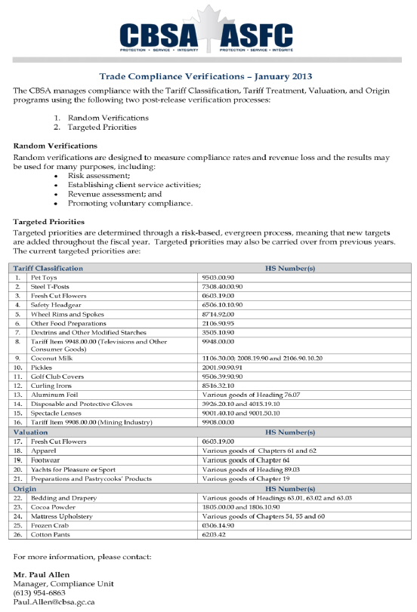

ATTACHMENT B
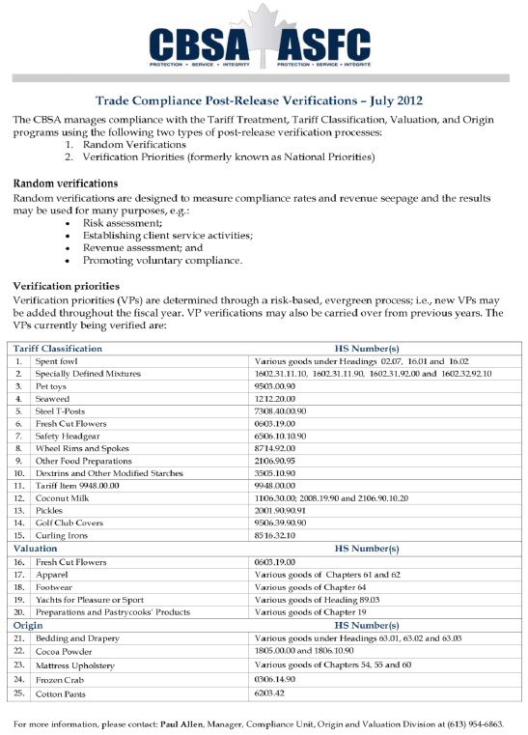

Footnotes
1. See Appendix A.
2. See Appendix B.
3. Canada, Jobs, Growth and Long-Term Prosperity: Economic Action Plan 2013 (21 March 2013), online Budget 2013 <http://www.budget.gc.ca> at 211 [Budget 2013].
4. Ibid at 223.
5. Ibid at 224.
6. Ibid.
7. Ibid at 134.
8. Ibid at 135.
9. Ibid at 271.
10. Canada, Canada Gazette, Vol 146 No 51 (22 December 2012).
11. Budget 2013, supra note 3 at 135.
12. "Negotiations and Agreements: Free Trade Agreements" (7 June 2013), online: Foreign Affairs, Trade and Development Canada <http://www.international.gc.ca/>.
13. "Trans-Pacific Partnership Free Trade Agreement Negotiations" (27 June 2013), online: Foreign Affairs, Trade and Development Canada <http://www.international.gc.ca/>.
14. "Trans-Pacific Partnership Free Trade Agreement Negotiations: Background Information" (26 June 2013), online: Foreign Affairs, Trade and Development Canada <http://www.international.gc.ca/>.
15. Foreign Affairs, Trade and Development Canada, News Release, "Harper Government Advances Pro-Trade Plan for Jobs, Growth and Long-Term Prosperity at Latest Round of Trans-Pacific Partnership Negotiations" (24 May 2013), online: Foreign Affairs, Trade and Development Canada <http://www.international.gc.ca/>.
16. "Outlines of the Trans-Pacific Partnership Agreement" (November 2011), online: Office of the United States Trade Representative <http://www.ustr.gov/>.
17. Martha Hall Findley, "Supply Management: Problems, Politics – and Possibilities" (2012) 5:19 University of Calgary School of Public Policy Research Papers at 13, online: University of Calgary School of Public Policy <http://policyschool.ucalgary.ca/>.
18. "EICS/EXCOL Bulletin – Introducing EICS-II: System Replacement Project" (24 June 2013), online: Foreign Affairs, Trade and Development Canada <http://www.international.gc.ca/>.
19. "Export Import Control System II (ECIS-II): Frequently Asked Questions (FAQ)" (24 May 2013), online: Foreign Affairs, Trade and Development Canada <http://www.international.gc.ca/>.
20. "About eManifest" (27 May 2013), Canada Border Services Agency <http://www.cbsa.gc.ca/>.
21. "Frequently Asked Questions (FAQs)" (26 February 2013), online: Canada Border Services Agency <http://www.cbsa.gc.ca/>.
22. Ibid.
23. "Implementing eManifest" (28 May 2013), online: Canada Border Services Agency <http://www.cbsa.gc.ca/>.
24 Ibid.
25. Ibid.
26. Ibid.
27. Canada Border Services Agency, Customs Notice 13-001, "Increase to the Value Threshold for Exemption From the North American Free Trade Agreement (NAFTA) Certificate of Origin Requirements for Commercial Goods for Which Preferential Treatment Under NAFTA is Claimed" (8 January 2013), online Canada Border Services Agency <http://www.cbsa.gc.ca/>.
28. Canada Border Services Agency, News Release "Canada increases and harmonizes low-value shipment threshold with the United States" (8 January 2013), online: Canada Border Services Agency <http://www.cbsa.gc.ca/>.
29. Ibid.
30. Canada Border Services Agency, Customs Notice 13-011, "Changes to the Administration of the Trade-related Administrative Monetary Penalties" (24 May 2013) online Canada Border Services Agency <http://www.cbsa.gc.ca/>.
31. Ibid.
32. Meagan Fitzpatrick, "Border agency drops rule for iPod tax exemption: Consumers, importers won't have to certify how iPods are used, CBSA says" (2 July 2013), online: CBC News <http://www.cbc.ca/news/>.
33. Ibid.
34. Ibid.
35. Canada Border Services Agency, Customs Notice 13-015, "Clarification of the Imported Goods Records Regulations" (28 June 2013), online: Canada Border Services Agency <http://www.cbsa.gc.ca/>.

View Terms and Conditions and Privacy Policy
Help desk: Mon-Fri, 9am-5pm ET 1-866-256-6842 Contact Us
© 2001-2024, EYEP and/or E&Y LLP and/or CPA Canada. All rights reserved.

